

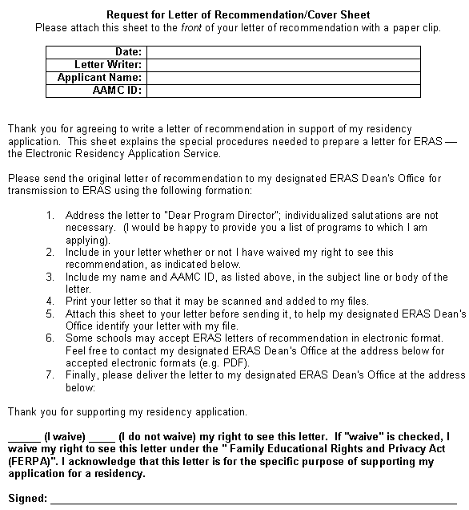
Designated ERAS Dean's Office Mailing Address
School: | Stony Brook University School of Medicine
Dept: | Office of Medical Education
Address: | HSC, Level 4, Room 158
City: | Stony Brook | ST: | NY |  |  |  | Zip: | 11794-8432
Phone: | 631-444-1030 |  |  |  | * Fax:
Email:
* Check if your school accepts faxed documents before providing a fax number

