Gray Matter
  - Dorsomarginal nucleus (rexed lamina 1)
    - Receives and processes sensory input
    - Found at all levels
    - Light touch, pain, temperature sensation
    - One of the sites of origin of the ventral and lateral spinothalamic tracts
  - Substantia gelatinosa
    - All cord levels
    - Homologous to the spinal trigeminal nucleus
    - Light touch, pain, temperature
    - Integrates input for the ventral and lateral spinothalamic tracts
  - Nucleus proprius (lamina 3 and 4)
    - All levels
    - Light touch, pain and temperature
    - Gives rise to the ventral and lateral spinothalamic tracts
  - Nucleus of clarke (Lamina 7)
    - Base of the dorsal horn
    - T1-L3
    - Homologous to the Accessory Cuneate Nucleus in the medulla
    - Subserves unconscious proprioception from muscle spindles and Golgi Tendon Organs
    - Origin of the Dorsal Spino Cerebellar tract
  - Lateral Horn
    - Viscerosensory input
    - Found between dorsla and ventral horns
    - T1-L3
    - Contains the interomediolateral nucleus a visceromotor nucleus
  - Ventral horn (lamina 7,8,9)
    - Predominately motor nuclei
    - Found at all levels

- White matter with three major divisions
  - Dorsal funiculus (column)
    - Fasciculus gracilis : between the dorsal medium sulcus and the dorsal intermediate sulcus and septum, found at all levels
    - Fasciculus cuneatus: located between the dorsal median sulcus and the dorsal lateral sulcus. Found C1-T6
  - Lateral funiculus
    - Located between the dorsal and lateral and ventral lateral sulci
  - Ventral funiculus
    - Between the ventral median fissure and the ventral lateral sulcus
    - Contains the ventral white commissure
      - Located between the central canal and the ventral median fissure
      - Contains decussating spinothalamic tracts

How to determine spinal level
- Cervical cord
  - Dorsal and intermediate sulci and spta are present
  - Ventral horns are massive from C3 to C8
- Thoracic
  - Dorsal and intermediate septa are found from T1 thru 6
  - Nucleus of clarke is found from throughout… most prominently from T11 to T12
  - Lateral horns
  - Slender H shaped dorsal and ventral horns
- Lumbar cord
  - Nucleus of clarke is very prominent at L1 to 2
  - Massive dorsal horns from L2 to 5
  - Enlarged substantia gelatinosa
  - Lateral horn is only seen at L1
- Sacral cord
  - Contains massive ventral and dorsla horns
  - Enlarged substantia gelatinosa
  - Reduced in diameter in S3 to S5

Ascending pathways
- First order neuron is always the dorsal root ganglion
- Usually decussates before the cortex
- 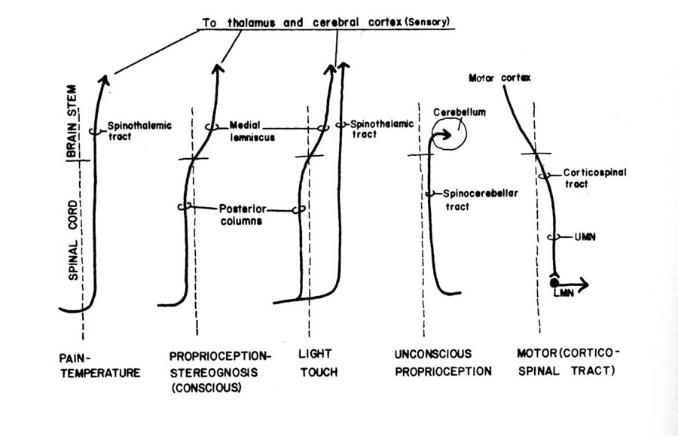

- Dorsal column medial lemniscus pathway
  - Tactile discrimination, vibration, form recognition, joint and muscle sensation
  - Proprioception

  - First order neurons
    - Located in the DRG
    - Rise as the fasciculus gracilis from the lower extremities
    - Rise as the fasciculus cuneatus from the upper extremities
    - Terminate in the gracile and cuneate nuclei in the medulla

  - Second order neurons
    - Located in the gracile and cuneate nuclei in the caudal medulla
    - Gives rise to axons, internal arcuate fibers that decussate and form a compact fiber bundle called the medial lemniscus.
    - The medial lemniscus ascends through the contralateral brainstem to terminate in the VPL of the thalmus
  - Third order neurons
    - Located in the VPL
    - Project via the posterior limb of the internal capsule to the postcentral gyrus, the somatosensory cortex

- Ventral spinothalamic tract
  - Light touch
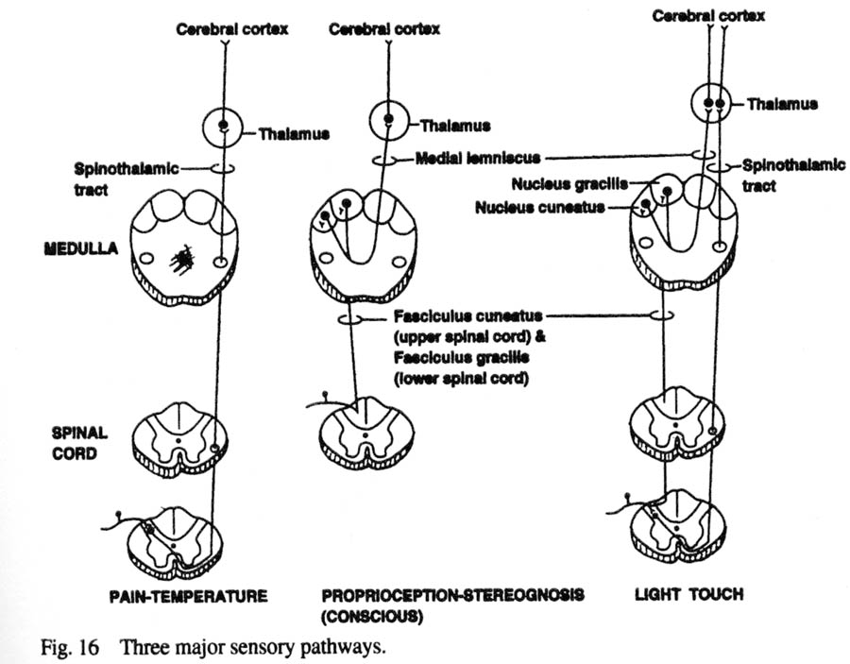
  - First order neurons
    - Found in the dorsal root ganglion at all levels
    - Project to the 2nd order neurons in the dorsal horn
  - Second order neurons
    - Located in the dorsal horn
    - Axons decussate in the ventral white commissure and ascend in the contralteral ventral funiculus
    - Terminate in the VPL of the thalmus
  - Third order neurons
    - In the VPL
    - Project via the posterior limb of the internal capsule and corona radiata to the somatosensory cortex

Lateral spinothalamic tract
  - Mediates pain and temperature sensation
  - Input from Aδ and C fibers
  - Somatotopical organization with the sacral fibers dorsolateral and the cervical fibers ventromedially

  - First order neurons
    - Found in the DRG at all levels
    - Project via the dorsolateral tract of Lissauer to second order neurons in the dorsal horn
    - Synapse with second order neurons in the dorsal horn
  - Second order neurons
    - Found in the dorsal horn
    - Give rise to axons decussating in the ventral white commissure and ascend in the ventral half of the lateral funiculus
    - Projects to the contralateraly to the reticular formation
    - Terminate contralaterally in the VPL nucleus and bilaterally in the intralaminar nuclei of the thalmus
  - Third order neurons
    - Are found in the VPL nucleus and
    - Intralaminar nuclei of the thalmus
    - VPL neurons
      - Project via the posterior limb of the internal capsule to the somatesthetic cortex of the postcentral gyrus
    - Intralaminar neurons
      - Projects to the caudate, putamen and the to the frontal and parietal cortex

Dorsal spinocerebellar tract
  - Transmits unconscious proprioceptive information to the cerebellum
  - Concerned with coordinated movement and posture of the lower extremity
  - Remains ipsilateral
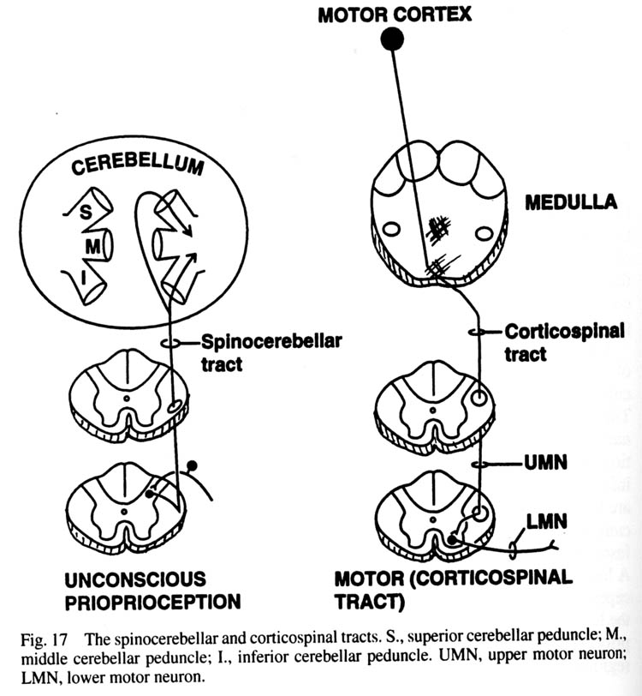
  - First order neurons
    - DRG of L1 to S2
    - Provide the sensory component to the muscle stretch reflex
    - Project to the nucleus dorsalis of Clarke
  - Second order neurons
    - Found in the nucleus dorsalis of Clarke (C8 – L3)
    - Gives rise to axons that ascend in the lateral funiculus
    - Reach the cerebellum via the inferior cerebellar peduncles
    - Terminate ipsilaterally as mossy fibers in the cortex of the rostral and caudal cerebellar vermis

Ventral spinocerebellar tract
  - Transmits unconscious proprioceptive information to the cerebellum
  - Crosses the midline

  - First order neurons
    - Found in the DRG in L1 to S2
    - Provide the afferent limb of muscle stretch reflexes
    - Synapse on spinal border cells
  - Second order neurons
    - Found in the ventral horns in L1 to S2
    - Gives rise to axons that decussate in the ventral white commissure and ascend lateral to the spinothalamic tract in the lateral funiculus
    - Gives rise to axons that enter the cerebellum via the superior cerebellar peduncle and terminate in contralateral rostral cerebellar vermis

Cuneocerebellar tract
  - Upper extremity equivalent of the dorsal spinocerebellar tract

  - First order neurons
    - Found in the DRG from C2 to T7
    - Project their axons via the fasciculus cuneatus to the accessory cuneate nucleus a homolog of the nucleus dorsalis of Clarke
  - Second order neurons
    - Located in the accessory cuneate nucleus in the medulla
    - Gives rise to axons that project to the cerebellum via the inferior cerebellar peduncle these axons terminate ipsilaterally in the arm region of the anterior lobe of the cerebellum

Descending spinal tracts
- Concerned with Somatic and visceral motor
- Have the cells of origin in the cerebral cortex or in the brain stem

Lateral corticospinal (pyramidal) tract
Function
  - Volitional skilled motor activity, primarily of the limbs
  - Modulates the transmission

Lesions:
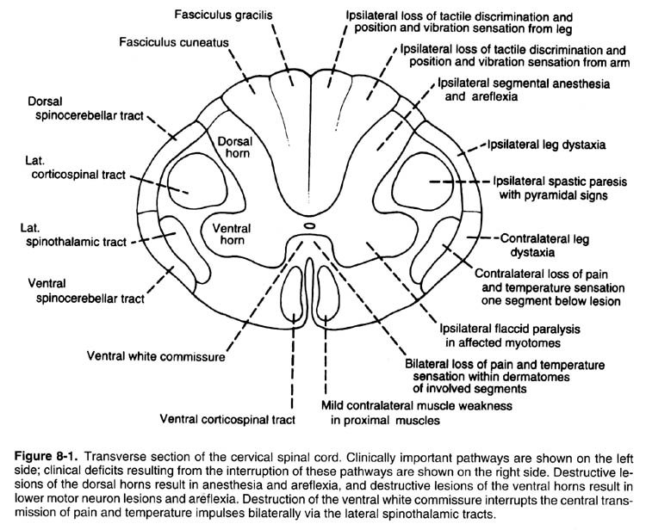
Fasciculus Gracilis;
- Ipsilateral loss of tactile discrimination, proprioception, and vibration sensation from leg
Fasciculus Cuneatus:
- Ipsilateral loss of tactile discrimination, proprioception, and vibaration from arm
Dorsal Horn
- Ipsilateral segmental anesthesia and areflexia
Dorsal Spinocerebellar tract
- Ipsilateral leg dystaxia (lack of coordination in the execution of voluntary movement)
Ventral spinocerebellar tract
- Contralateral leg dystaxia
Lateral corticospinal tract
- Ipsilateral spastic paresis (partial or incomplete paralysis)
Ventral corticospinal tract:
- Mild contralateral muscle weakness in proximal muscles
Lateral spinothalmic tract
- Contralateral loss of pain and temperature sensation one segment below lesion
Ventral Spinothalmic tract:
- Contralateral loss of crude touch sensation starting one segment below the lesion
Ventral horn:
- Ipsilateral flaccid paralysis in affected myotomes
Ventral white commisure:
- Bilateral loss of pain and temperature sensation within dermatomes of involved segments

Brown Sequard syndrome would be the equivalent of having all of these at the same time.
- Loss of contralateral pain and temperature, distal to the site of lesion, starting one segment distal to injury
- Ipsilateral loss of tactile discrimination, proprioception vibration, and spastic paresis, distal to the sight of lesion starting one segment distal
- Complete anesthesia in the dermatome corresponding to the injury

Lesions with Contralateral effects
- Ventral spinocerebellar tracts
- Lateral spinothalmic tract
- Ventral corticospinal tract
- Ventral white commissure (ipsilateral as well)

Lesions with Ipsilateral effects
- Fasciculus gracilis
- Fasciculus cuneatus
- Dorsal horn
- Dorsal spinocerebellar tract
- Lateral corticospinal tract
- Ventral horn

Development
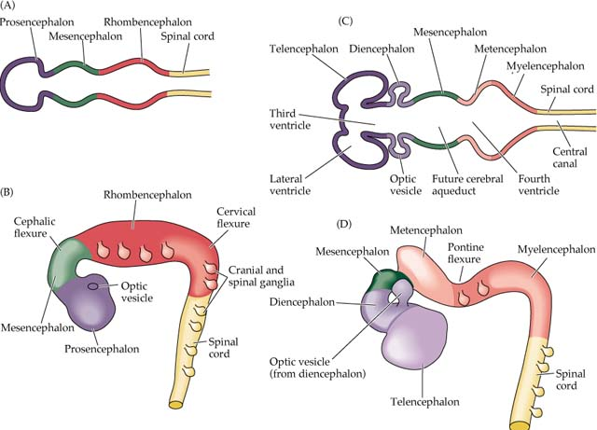
- Three vessicle stage
  - Prosencephalon (forebrain)
  - Mesencephalon (midbrain)
  - Rhombencephalon (hindbrain)

- Five vessicle stage
  - Telencephalon
    - From the prosencephalon
    - Becomes the cerebral hemispheres
    - Becomes the lateral ventricles
  - Diencephalon
    - From the prosencephalon
    - Becomes the thalmus
    - Makes the third ventricle
  - Mesencephalon
    - Becomes the midbrain
    - Makes the cerebral aqueduct
  - Metencephalon
    - From the rhombencephalon
    - Becomes the pons and cerebellum
    - Makes the upper part of the 4th ventricle
  - Myelencephalon
    - From the rhombencephalon
    - Becomes the medulla
    - Makes the lower part of the 4th ventricle

CNS – Derived from
  - the neural tube from cells dividing in the ventricular zone and other extragerminal matrices
    - become
      - all neurons within the CNS
      - astroglia
      - radial glia
      - oligodendrocytes
      - ependymal cells
      - microglia

PNS – Derived from
  - Neural crest cells
    - Become
      - Psuedounipolar ganglion cells of cranial and spinal ganglia
      - Schwann cells
      - Multipolar ganglion cells of the autonomic ganglia
      - Leptomeninges
      - Chromaffin cells of the suprarenal medulla
      - Pigment cells
      - Odontoblasts
      - Aorticopulmonary septum of the heart
      - Parafollicaular cells
      - Skeletal and connective components of the pharyngeal arches
  - Neural tube
    - Preganglionic autonomic fibers, and fibers innervating skeletal muscles
  - Mesoderm
    - Dura mater and the connective tissue investments of peripheral nerve fibers

